正确填涂方式: |  |  |  |  |  |  |  |  |  |  |  |  |  |  |  |  | [ 0 ] | [ 0 ] | [ 0 ] | [ 0 ] | [ 0 ] | [ 0 ] | [ 0 ] | [ 0 ] | [ 0 ]
 |  |  |  |  |  |  |  |  |  |  |  |  |  |  |  |  | [ 1 ] | [ 1 ] | [ 1 ] | [ 1 ] | [ 1 ] | [ 1 ] | [ 1 ] | [ 1 ] | [ 1 ]
选择题（共100分） |  |  |  |  |  |  |  |  |  |  |  |  |  |  |  |  | [ 2 ] | [ 2 ] | [ 2 ] | [ 2 ] | [ 2 ] | [ 2 ] | [ 2 ] | [ 2 ] | [ 2 ]
1. | [ A ] | [ B ] | [ C ] |  | 6. | [ A ] | [ B ] | [ C ] |  | 11. | [ A ] | [ B ] | [ C ] |  |  |  | [ 3 ] | [ 3 ] | [ 3 ] | [ 3 ] | [ 3 ] | [ 3 ] | [ 3 ] | [ 3 ] | [ 3 ]
2. | [ A ] | [ B ] | [ C ] |  | 7. | [ A ] | [ B ] | [ C ] |  | 12. | [ A ] | [ B ] | [ C ] |  |  |  | [ 4 ] | [ 4 ] | [ 4 ] | [ 4 ] | [ 4 ] | [ 4 ] | [ 4 ] | [ 4 ] | [ 4 ]
3. | [ A ] | [ B ] | [ C ] |  | 8. | [ A ] | [ B ] | [ C ] |  | 13. | [ A ] | [ B ] | [ C ] |  |  |  | [ 5 ] | [ 5 ] | [ 5 ] | [ 5 ] | [ 5 ] | [ 5 ] | [ 5 ] | [ 5 ] | [ 5 ]
4. | [ A ] | [ B ] | [ C ] |  | 9. | [ A ] | [ B ] | [ C ] |  | 14. | [ A ] | [ B ] | [ C ] |  |  |  | [ 6 ] | [ 6 ] | [ 6 ] | [ 6 ] | [ 6 ] | [ 6 ] | [ 6 ] | [ 6 ] | [ 6 ]
5. | [ A ] | [ B ] | [ C ] |  | 10. | [ A ] | [ B ] | [ C ] |  | 15. | [ A ] | [ B ] | [ C ] |  |  |  | [ 7 ] | [ 7 ] | [ 7 ] | [ 7 ] | [ 7 ] | [ 7 ] | [ 7 ] | [ 7 ] | [ 7 ]
 |  |  |  |  |  |  |  |  |  |  |  |  |  |  |  |  | [ 8 ] | [ 8 ] | [ 8 ] | [ 8 ] | [ 8 ] | [ 8 ] | [ 8 ] | [ 8 ] | [ 8 ]
16. | [ A ] | [ B ] | [ C ] |  | 21. | [ A ] | [ B ] | [ C ] | [ D ] |  | 26. | [ A ] | [ B ] | [ C ] | [ D ] |  | [ 9 ] | [ 9 ] | [ 9 ] | [ 9 ] | [ 9 ] | [ 9 ] | [ 9 ] | [ 9 ] | [ 9 ]
17. | [ A ] | [ B ] | [ C ] |  | 22. | [ A ] | [ B ] | [ C ] | [ D ] |  | 27. | [ A ] | [ B ] | [ C ] | [ D ]
18. | [ A ] | [ B ] | [ C ] |  | 23. | [ A ] | [ B ] | [ C ] | [ D ] |  | 28. | [ A ] | [ B ] | [ C ] | [ D ]
19. | [ A ] | [ B ] | [ C ] |  | 24. | [ A ] | [ B ] | [ C ] | [ D ] |  | 29. | [ A ] | [ B ] | [ C ] | [ D ]
20. | [ A ] | [ B ] | [ C ] |  | 25. | [ A ] | [ B ] | [ C ] | [ D ] |  | 30. | [ A ] | [ B ] | [ C ] | [ D ]
31. | [ A ] | [ B ] | [ C ] | [ D ] |  | 36. | [ A ] | [ B ] | [ C ] | [ D ] | [ E ] | [ F ] | [ G ] |  | 41. | [ A ] | [ B ] | [ C ] | [ D ] |  | 46. | [ A ] | [ B ] | [ C ] | [ D ]
32. | [ A ] | [ B ] | [ C ] | [ D ] |  | 37. | [ A ] | [ B ] | [ C ] | [ D ] | [ E ] | [ F ] | [ G ] |  | 42. | [ A ] | [ B ] | [ C ] | [ D ] |  | 47. | [ A ] | [ B ] | [ C ] | [ D ]
33. | [ A ] | [ B ] | [ C ] | [ D ] |  | 38. | [ A ] | [ B ] | [ C ] | [ D ] | [ E ] | [ F ] | [ G ] |  | 43. | [ A ] | [ B ] | [ C ] | [ D ] |  | 48. | [ A ] | [ B ] | [ C ] | [ D ]
34. | [ A ] | [ B ] | [ C ] | [ D ] |  | 39. | [ A ] | [ B ] | [ C ] | [ D ] | [ E ] | [ F ] | [ G ] |  | 44. | [ A ] | [ B ] | [ C ] | [ D ] |  | 49. | [ A ] | [ B ] | [ C ] | [ D ]
35. | [ A ] | [ B ] | [ C ] | [ D ] |  | 40. | [ A ] | [ B ] | [ C ] | [ D ] | [ E ] | [ F ] | [ G ] |  | 45. | [ A ] | [ B ] | [ C ] | [ D ] |  | 50. | [ A ] | [ B ] | [ C ] | [ D ]
51. | [ A ] | [ B ] | [ C ] | [ D ] |  | 56. | [ A ] | [ B ] | [ C ] | [ D ]
52. | [ A ] | [ B ] | [ C ] | [ D ] |  | 57. | [ A ] | [ B ] | [ C ] | [ D ]
53. | [ A ] | [ B ] | [ C ] | [ D ] |  | 58. | [ A ] | [ B ] | [ C ] | [ D ]
54. | [ A ] | [ B ] | [ C ] | [ D ] |  | 59. | [ A ] | [ B ] | [ C ] | [ D ]
55. | [ A ] | [ B ] | [ C ] | [ D ] |  | 60. | [ A ] | [ B ] | [ C ] | [ D ]
以下为非选择答题区，必须用黑色字迹的钢笔或签字笔在指定的区域内作答，否则答案无效。
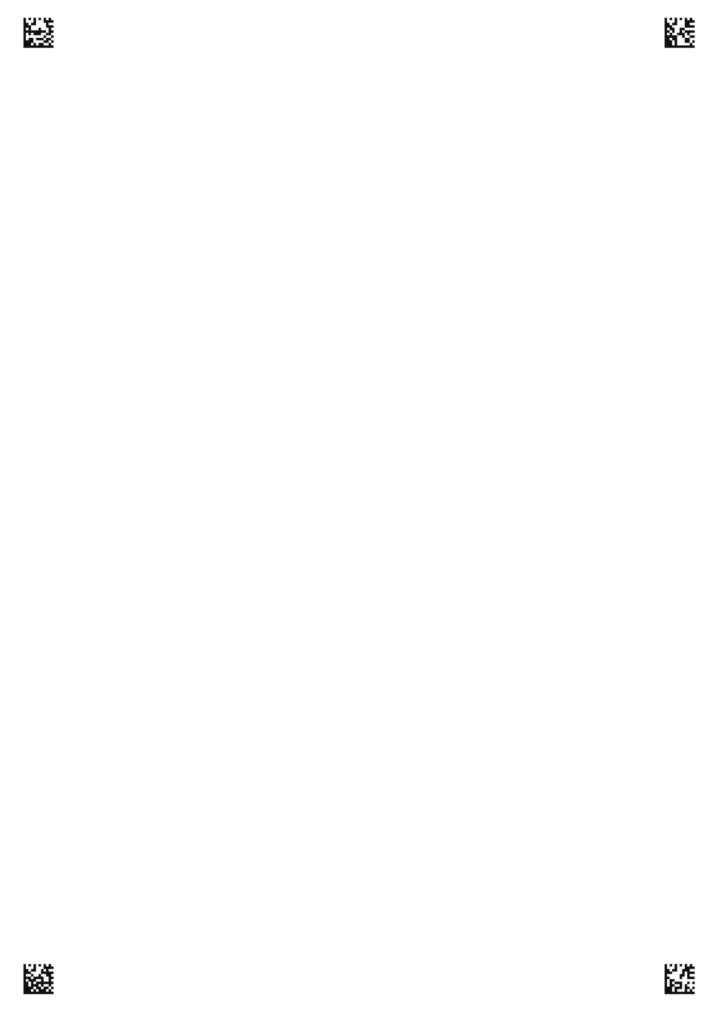
学 号
姓 名: 班 级:
考场号: 座位号:
海南省农垦中学20**届高二**学期**考试—英语答题卡
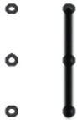
第三部分 第二节 语法填空（共10小题：每小题1.5分，满分15分）
61. 62. 63.
64. 65. 66.
67. 68. 69.
70.

高二英语 第 页（共2页）
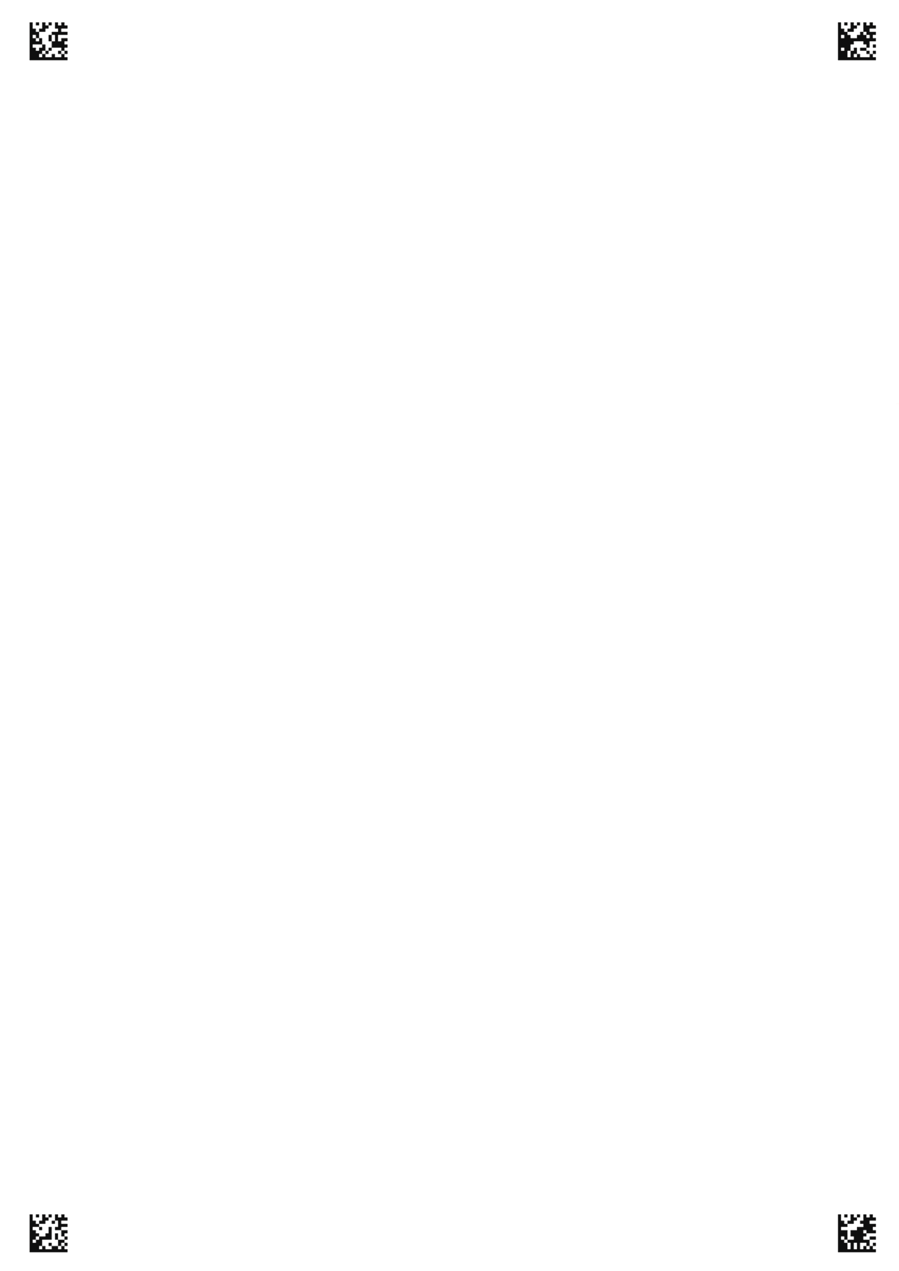
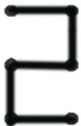
第四部分 写作（共两节，满分35分）
第一节 短文改错（共10小题；每小题1分，满分10分）
This morning I went to People’s Park as usually. I took part in an English activity calling “English Corner” there every Sunday. When I was practicing English here with some friends, two America students came. We were both interested in sports. I told them I liked to play volleyball. They said they also liked it and we were even members of their school’s volleyball team. We talked about some rules, some famous players and other things about the volleyball. We were all happy that share the same interest can not only build up our body, but got us new friends. I like this kind conversation, because I can practice my English as well as learn some other useful things.

第二节：书面表达（满分25分）

高二英语 第 页（共2页）

