正确填涂方式: |  |  |  |  |  |  |  |  |  |  |  |  |  |  |  |  | [ 0 ] | [ 0 ] | [ 0 ] | [ 0 ] | [ 0 ] | [ 0 ] | [ 0 ] | [ 0 ] | [ 0 ]
 |  |  |  |  |  |  |  |  |  |  |  |  |  |  |  |  | [ 1 ] | [ 1 ] | [ 1 ] | [ 1 ] | [ 1 ] | [ 1 ] | [ 1 ] | [ 1 ] | [ 1 ]
选择题（共100分） |  |  |  |  |  |  |  |  |  |  |  |  |  |  |  |  | [ 2 ] | [ 2 ] | [ 2 ] | [ 2 ] | [ 2 ] | [ 2 ] | [ 2 ] | [ 2 ] | [ 2 ]
1. | [ A ] | [ B ] | [ C ] |  | 6. | [ A ] | [ B ] | [ C ] |  | 11. | [ A ] | [ B ] | [ C ] |  |  |  | [ 3 ] | [ 3 ] | [ 3 ] | [ 3 ] | [ 3 ] | [ 3 ] | [ 3 ] | [ 3 ] | [ 3 ]
2. | [ A ] | [ B ] | [ C ] |  | 7. | [ A ] | [ B ] | [ C ] |  | 12. | [ A ] | [ B ] | [ C ] |  |  |  | [ 4 ] | [ 4 ] | [ 4 ] | [ 4 ] | [ 4 ] | [ 4 ] | [ 4 ] | [ 4 ] | [ 4 ]
3. | [ A ] | [ B ] | [ C ] |  | 8. | [ A ] | [ B ] | [ C ] |  | 13. | [ A ] | [ B ] | [ C ] |  |  |  | [ 5 ] | [ 5 ] | [ 5 ] | [ 5 ] | [ 5 ] | [ 5 ] | [ 5 ] | [ 5 ] | [ 5 ]
4. | [ A ] | [ B ] | [ C ] |  | 9. | [ A ] | [ B ] | [ C ] |  | 14. | [ A ] | [ B ] | [ C ] |  |  |  | [ 6 ] | [ 6 ] | [ 6 ] | [ 6 ] | [ 6 ] | [ 6 ] | [ 6 ] | [ 6 ] | [ 6 ]
5. | [ A ] | [ B ] | [ C ] |  | 10. | [ A ] | [ B ] | [ C ] |  | 15. | [ A ] | [ B ] | [ C ] |  |  |  | [ 7 ] | [ 7 ] | [ 7 ] | [ 7 ] | [ 7 ] | [ 7 ] | [ 7 ] | [ 7 ] | [ 7 ]
 |  |  |  |  |  |  |  |  |  |  |  |  |  |  |  |  | [ 8 ] | [ 8 ] | [ 8 ] | [ 8 ] | [ 8 ] | [ 8 ] | [ 8 ] | [ 8 ] | [ 8 ]
16. | [ A ] | [ B ] | [ C ] |  | 21. | [ A ] | [ B ] | [ C ] | [ D ] |  | 26. | [ A ] | [ B ] | [ C ] | [ D ] |  | [ 9 ] | [ 9 ] | [ 9 ] | [ 9 ] | [ 9 ] | [ 9 ] | [ 9 ] | [ 9 ] | [ 9 ]
17. | [ A ] | [ B ] | [ C ] |  | 22. | [ A ] | [ B ] | [ C ] | [ D ] |  | 27. | [ A ] | [ B ] | [ C ] | [ D ]
18. | [ A ] | [ B ] | [ C ] |  | 23. | [ A ] | [ B ] | [ C ] | [ D ] |  | 28. | [ A ] | [ B ] | [ C ] | [ D ]
19. | [ A ] | [ B ] | [ C ] |  | 24. | [ A ] | [ B ] | [ C ] | [ D ] |  | 29. | [ A ] | [ B ] | [ C ] | [ D ]
20. | [ A ] | [ B ] | [ C ] |  | 25. | [ A ] | [ B ] | [ C ] | [ D ] |  | 30. | [ A ] | [ B ] | [ C ] | [ D ]
31. | [ A ] | [ B ] | [ C ] | [ D ] |  | 36. | [ A ] | [ B ] | [ C ] | [ D ] | [ E ] | [ F ] | [ G ] |  | 41. | [ A ] | [ B ] | [ C ] | [ D ] |  | 46. | [ A ] | [ B ] | [ C ] | [ D ]
32. | [ A ] | [ B ] | [ C ] | [ D ] |  | 37. | [ A ] | [ B ] | [ C ] | [ D ] | [ E ] | [ F ] | [ G ] |  | 42. | [ A ] | [ B ] | [ C ] | [ D ] |  | 47. | [ A ] | [ B ] | [ C ] | [ D ]
33. | [ A ] | [ B ] | [ C ] | [ D ] |  | 38. | [ A ] | [ B ] | [ C ] | [ D ] | [ E ] | [ F ] | [ G ] |  | 43. | [ A ] | [ B ] | [ C ] | [ D ] |  | 48. | [ A ] | [ B ] | [ C ] | [ D ]
34. | [ A ] | [ B ] | [ C ] | [ D ] |  | 39. | [ A ] | [ B ] | [ C ] | [ D ] | [ E ] | [ F ] | [ G ] |  | 44. | [ A ] | [ B ] | [ C ] | [ D ] |  | 49. | [ A ] | [ B ] | [ C ] | [ D ]
35. | [ A ] | [ B ] | [ C ] | [ D ] |  | 40. | [ A ] | [ B ] | [ C ] | [ D ] | [ E ] | [ F ] | [ G ] |  | 45. | [ A ] | [ B ] | [ C ] | [ D ] |  | 50. | [ A ] | [ B ] | [ C ] | [ D ]
51. | [ A ] | [ B ] | [ C ] | [ D ] |  | 56. | [ A ] | [ B ] | [ C ] | [ D ]
52. | [ A ] | [ B ] | [ C ] | [ D ] |  | 57. | [ A ] | [ B ] | [ C ] | [ D ]
53. | [ A ] | [ B ] | [ C ] | [ D ] |  | 58. | [ A ] | [ B ] | [ C ] | [ D ]
54. | [ A ] | [ B ] | [ C ] | [ D ] |  | 59. | [ A ] | [ B ] | [ C ] | [ D ]
55. | [ A ] | [ B ] | [ C ] | [ D ] |  | 60. | [ A ] | [ B ] | [ C ] | [ D ]
以下为非选择答题区，必须用黑色字迹的钢笔或签字笔在指定的区域内作答，否则答案无效。
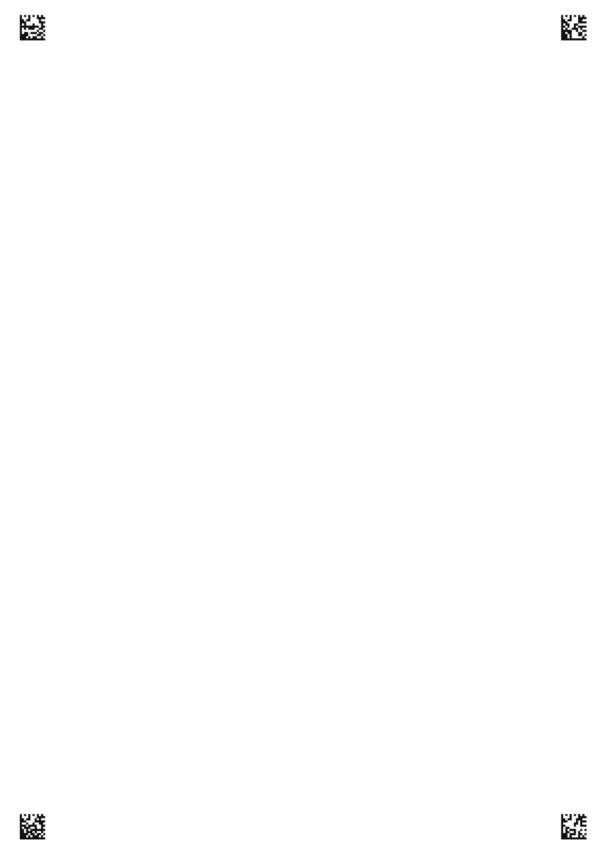
学 号
姓 名: 班 级:
考场号: 座位号:
海南省农垦中学20**届**学期**考试–高一英语答题卡

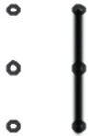
第三部分 第二节 语法填空（共15小题：每小题1分，满分15分）
61. 62. 63.
64. 65. 66.
67. 68. 69.
70. 71. 72.
73. 74. 75.
高一英语 第 页（共2页）
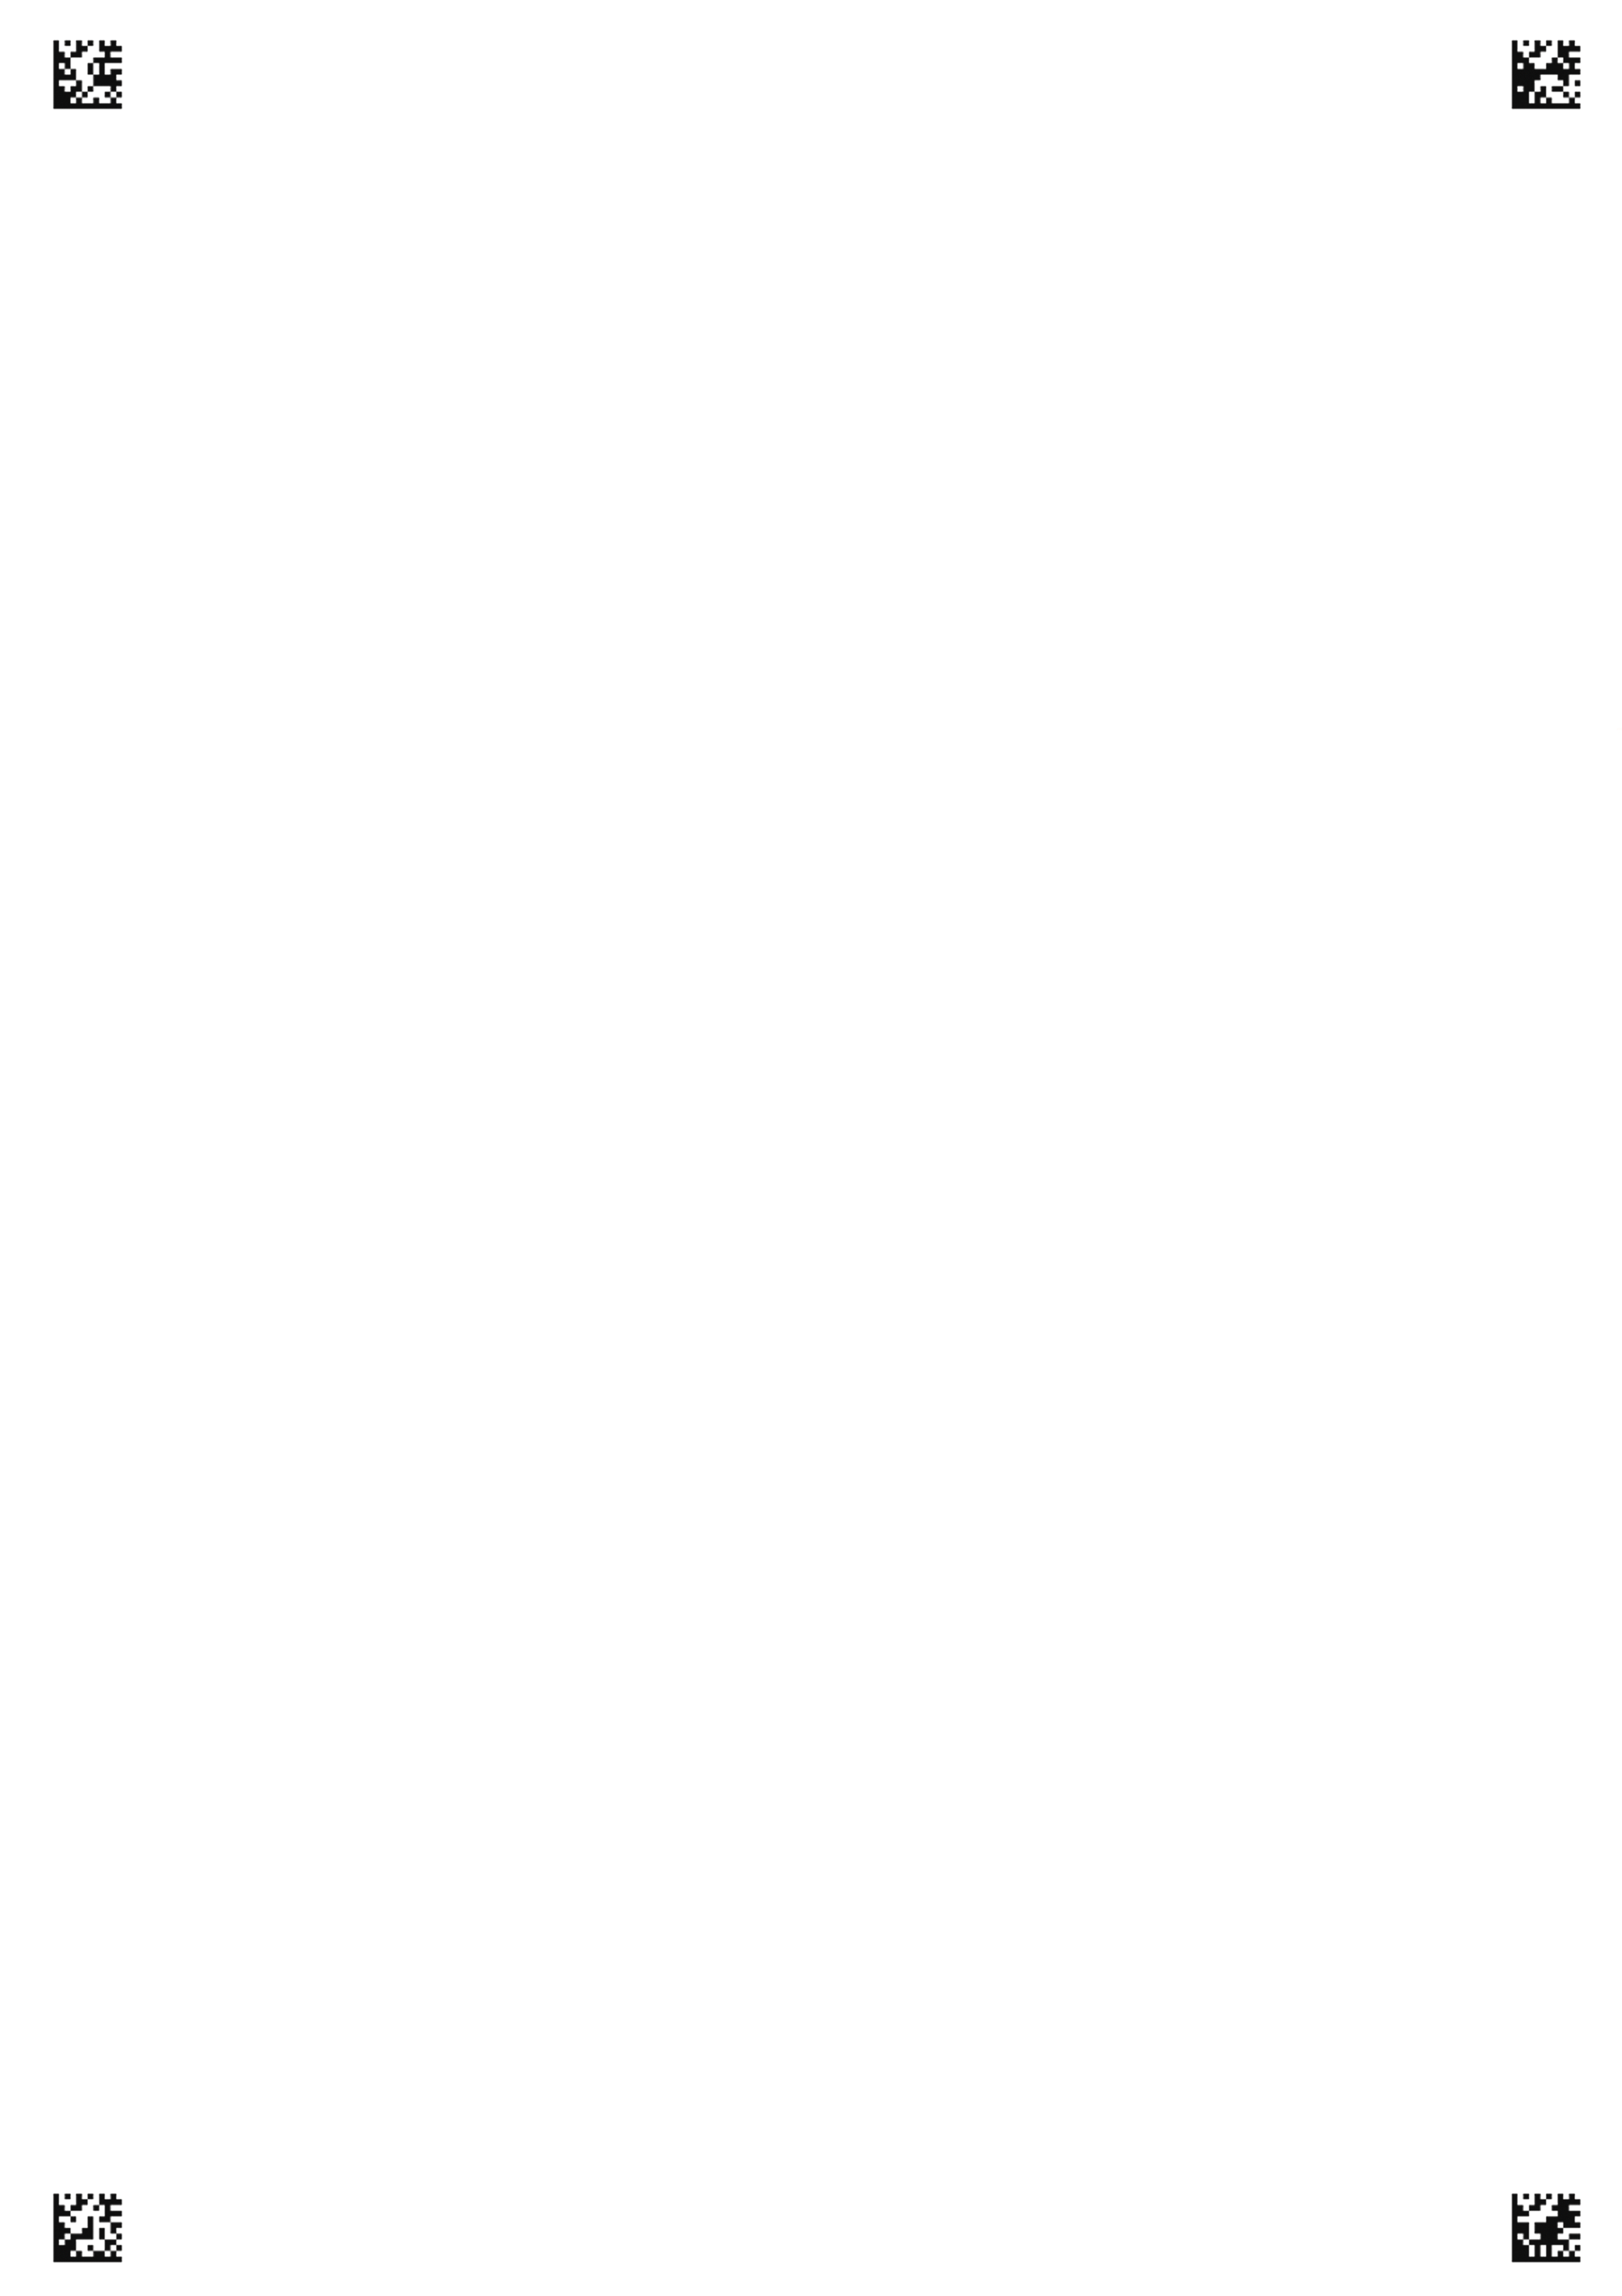
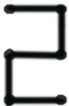
第四部分 写作（共两节，满分35分）
第一节 短文改错（共10小题；每小题1分，满分10分）
My neighbor Pat Anderson always shows great kindness and consider to others. One day we have an emergency in our family. My sister Lily were going to deliver a speech at an institute. I intended to taking her there, but our car would not start. I rushed into the street to hire taxi. Then sudden I came across Pat. She was going to the hospital, feared that she had caught the sickness that was going around the local area. Before she heard our problem, she rushed to home to get her car and took us there. The audience was already in the hall. They were only just in time!

第二节：书面表达（满分25分）

高一英语 第 页（共2页）

